# **HELP GUIDE FOR MOVING TO SCARBOROUGH TORONTO**

## **1. Introduction:**

The purpose of this Capstone Project is to help people in exploring better facilities around their neighborhood. It will help people making smart and efficient decision on selecting great neighborhood out of numbers of other neighborhoods in Scarborough, Toronto.

Many people are often migrating because of work placements. So people need to know some clear living location where every aspect of primary needs is in reach. Children needs also need to be look at so school information also important.

This Project aim to create an analysis of features for a people migrating to Scarborough to search a best neighborhood as a comparative analysis between neighborhoods. The features include median housing price and better school according to ratings, crime rates of that particular area, road connectivity, weather conditions, good management for emergency, water resources both freash and waste water and excrement conveyed in sewers and recreational facilities.

Hopefully this will help people who are planning on moving to Toronto.

## **2. Data Section**

Data Link: https://en.wikipedia.org/wiki/List_of_postal_codes_of_Canada:_M

Used for Scarborough dataset which we scrapped from Wikipedia.

#### Foursquare API Data:

Foursquare data to provide nearby venues or public areas.

The information obtained per venue as follows:

1. Neighborhood

2. Neighborhood Latitude

3. Neighborhood Longitude

4. Venue

5. Name of the venue e.g. the name of a store or restaurant

6. Venue Latitude

7. Venue Longitude

8. Venue Category

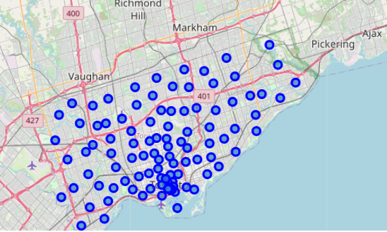

## **3. Methodology Section**

#### Clustering Approach:

To compare the similarities of two cities, we decided to explore neighborhoods, segment them, and group them into clusters to find similar neighborhoods in a big city like New York and Toronto. To be able to do that, we need to cluster data which is a form of unsupervised machine learning: k-means clustering algorithm.

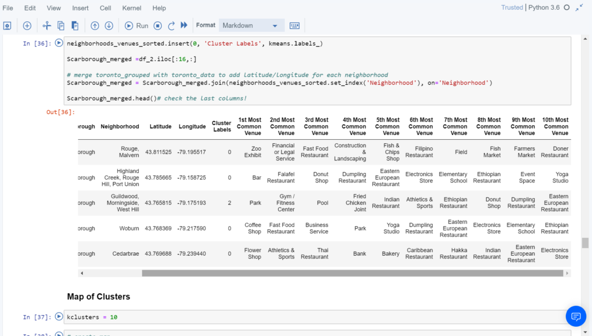

## **4. Results Section**

**Map of Clusters in Scarborough**

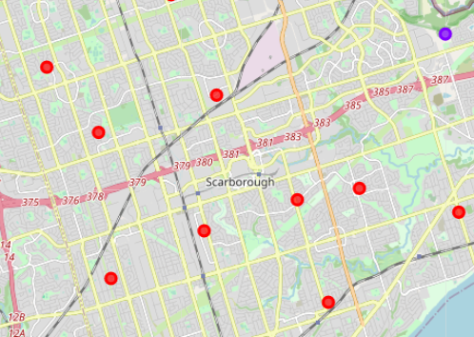

**Scaborough Average Housing Price**

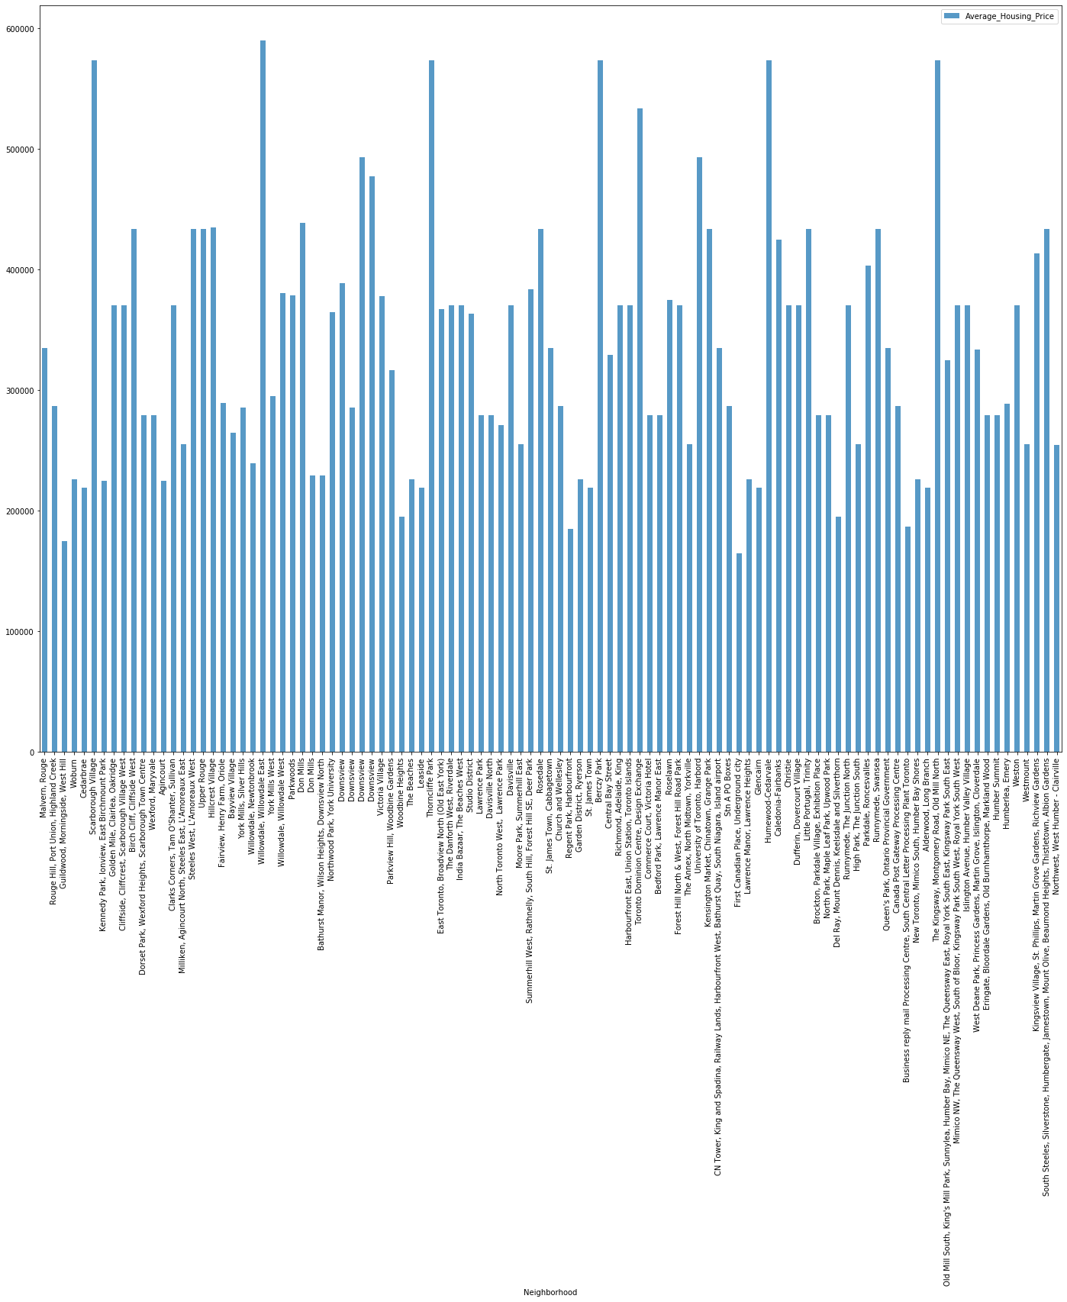

**Scaborough Top School Rating**

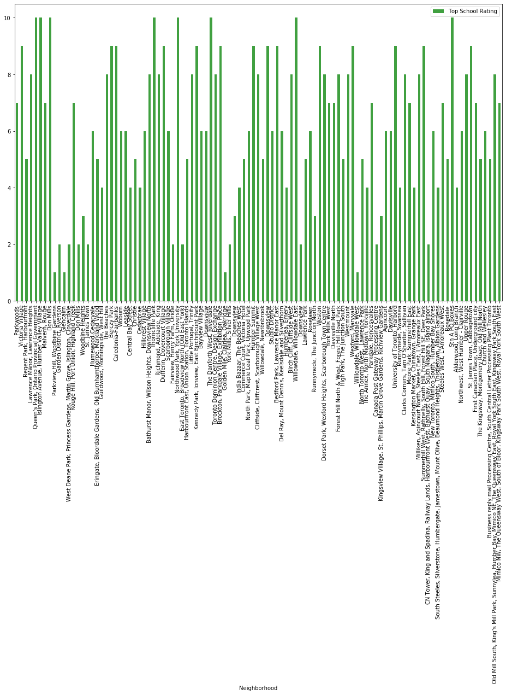

#### The Location:

Scarborough is a popular destination for new immigrants in Canada to reside. As a result, it is one of the most diverse and multicultural areas in the Greater Toronto Area, being home to various religious groups and places of worship. Although immigration has become a hot topic over the past few years with more governments seeking more restrictions on immigrants and refugees, the general trend of immigration into Canada has been one of on the rise.

#### Foursquare API:

This Capstone project have used Four-square API as its prime data gathering source as it has a database of millions of places, especially their places API which provides the ability to perform location search, location sharing and details about a business.

## **5. Discussion Section**

#### Problem Which Tried to Solve:

The major purpose of this project, is to suggest a better neighborhood in a new city for the person who are shiffting there. Social presence in society in terms of like minded people. Connectivity to the airport, bus stand, city center, markets and other daily needs things nearby.

* Sorted list of house in terms of housing prices in a ascending or descending order
* Sorted list of schools in terms of location, fees, rating and reviews

## **6. Conclusion Section**

In this Capstone project, using k-means cluster algorithm I separated the neighborhood into 10(Ten) different clusters and for 103 different lattitude and logitude from dataset, which have very-similar neighborhoods around them. Using the charts above results presented to a particular neighborhood based on average house prices and school rating have been made.

I feel rewarded with the efforts and believe this course with all the topics covered is well worthy of appreciation.  
This project has shown me a practical application to resolve a real situation that has impacting personal and financial impact using Data Science tools.  
The mapping with Folium is a very powerful technique to consolidate information and make the analysis and decision better with confidence.